Video : <https://www.youtube.com/watch?v=8re44RiaocY>

Cli link : <https://cloud.google.com/sdk/docs/install>

Command/steps:

gcloud init

2. configuration

2. new login

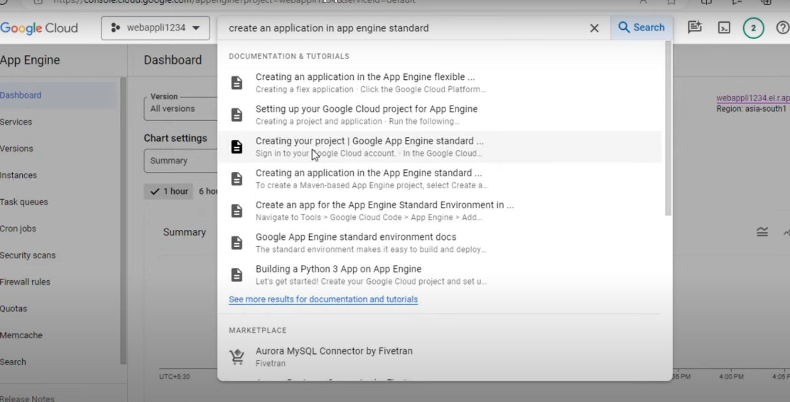

Inside app engine

Open app creation

Open shell

Command:

git clone <https://github.com/GoogleCloudPlatform/python-docs-samples.git>

cd python-docs-sample/appengine/standart_python3/hello_world

gcloud app deploy

gcloud app browse

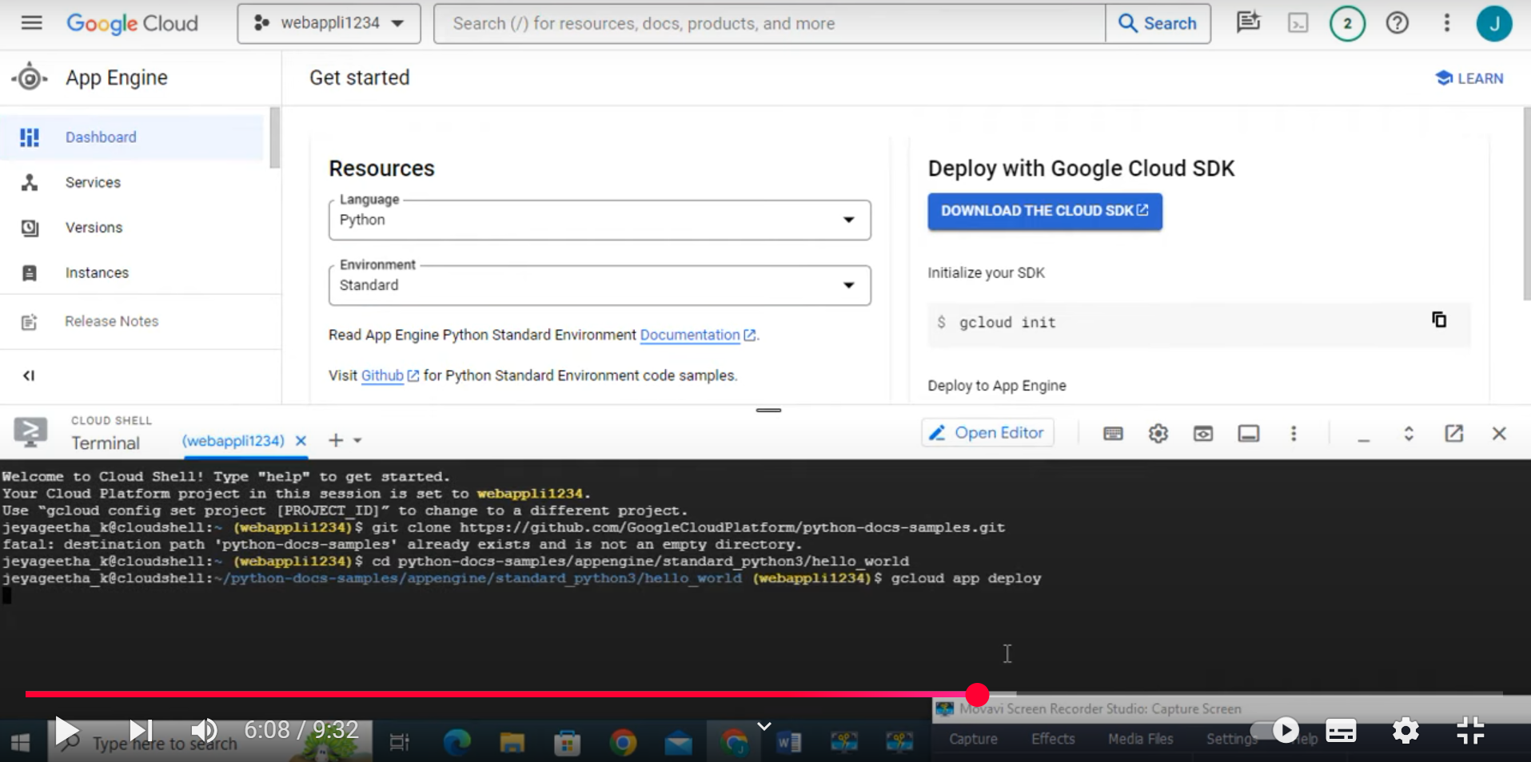

For local Deployment   
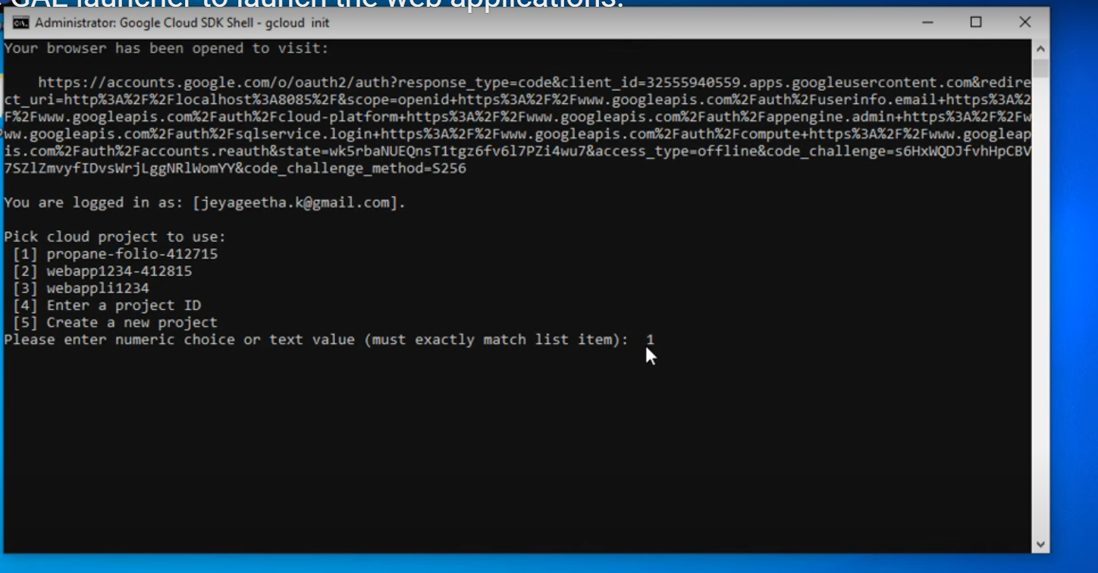

Select project

cd to file directory

gcloud app deploy

gcloud app browse